Web Fundamentals Final Lab
Objective
To assess what you’ve learned during the course.
Overview
In this test you’ll write code to practice using the web programming concepts which you’ve learned during the course. There are no detailed step by step instructions but you’ll find sufficient instructions for each task.
There is no pass/fail mark for this assessment; however, your work will be uploaded to Canvas as a record of the progress you have made on the course.
You will have 2 hours to complete this task.
a) Examine the web service
- First of all, you will run a web server on your own computer. To do this:
- Locate the WebService folder
- Double click on the Runme.bat file to run the web service
- When finished (but not yet!), press Ctrl-C to end the web server
- Open a web browser, then navigate to the following web service URLs:
  - http://localhost:5000/customers
  - http://localhost:5000/ordersbycustomerid/alfki
where alfki is the id of a customer
- Examine the output from the web service, which is in JSON format, and make sure you understand what it is doing. Understand that customers returns an array of customers, and ordersbycustomerid returns an array of orders.
Hint: You can copy and paste the JSON string into a web site such as http://jsonviewer.stack.hu/ to format it for easy reading
b) Build an Application
- You will now build a web application which will:
    - Show a list of customers in a table. Please only display the following attributes:
CustomerID, ContactName, City
    - Use CSS to highlight a table row when cursor hovers over.
    - When the user clicks on a customer row, your code should display orders by the selected customer in a separate table. Please see the example below this page.
Please show the following attributes:
OrderID, EmployeeID, ShipCountry, Freight
- You may choose whichever web technology you like from this course –
JavaScript, jQuery or AngularJS (recommended).
- You should decide what your web application will look like
(see the example below for a start).

Tip: To put the two tables side-by-side with a scrollbar you can use the simple CSS script below
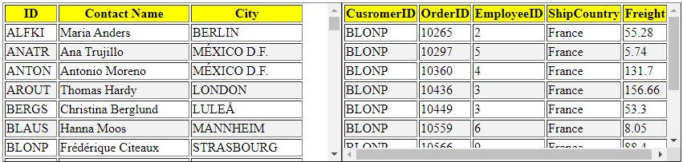
table {
display: block;
height: 200px;
width: 50%;
overflow: auto;
}

